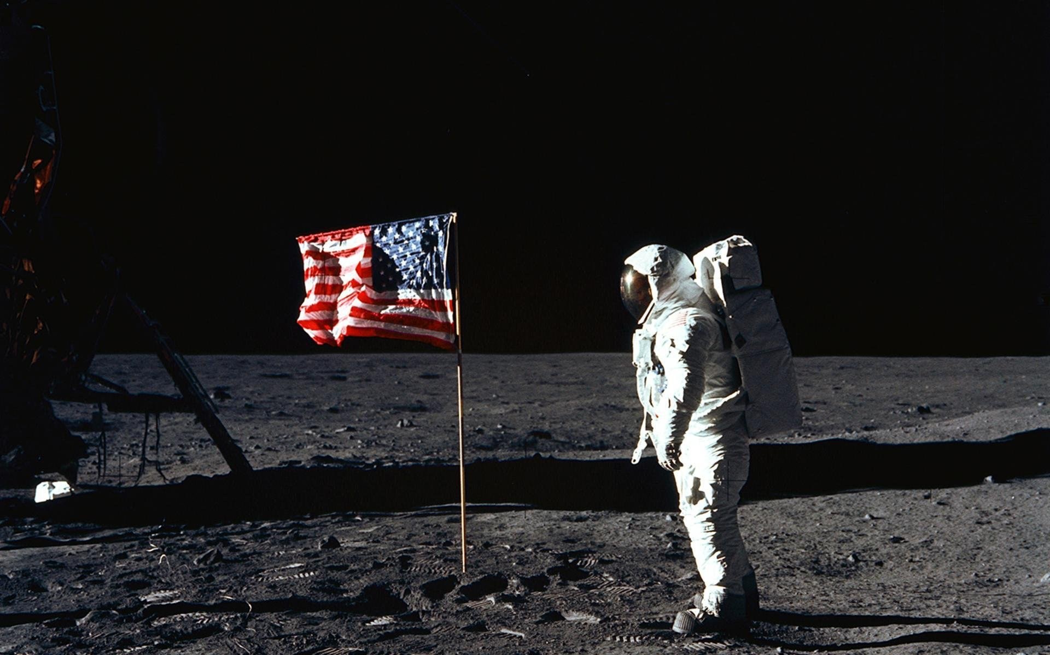

(Wall Devil , 2016)

***Computer Hardware Based*** Astronaut

Career Assignment

By: Devdigvijay Singh | ICS 207 | Teacher: Ms. Xie

# Detailed Job Description

## General Astronauts

Astronauts perform various tasks as they live in orbit around the Earth. For example, they are responsible for performing experiments that can’t be conducted on Earth due of the effect of gravity. They also maintain the International Space Station, along with fixing large satellites. In the near future, they will be responsible for being the first to colonize another planet in our Solar System.

Specifically, there are three main types of astronauts. Depending on your experience level and knowledge, you are assigned a role:

1. **Commander**The commander is responsible for the vehicle and more importantly, the crew members’ safety. Then, comes the success of the mission and the spacecraft. The commander is an astronaut that considers the thoughts of all members of the crew and make rational decisions under a tremendous amount of stress.
2. **Pilot**The pilot assists the commander in operating the vehicle and is also responsible for the deployment and retrieval of satellites. The pilot operates the remote manipulator system and also carries out payload operations. The pilot must also be able to make quick decisions that could mean life or death very quickly.
3. **Mission specialist**The mission specialist works hand in hand with the commander, and is responsible for the overall coordination of operations. The mission specialist is responsible for knowing all information relating to the current mission in case that information is needed at any time of the mission. Also, the mission specialist is the one that performs the Extra-Vehicular Activities (EVAs)

## Computer Programming / Computer Hardware Related Experiments on the International Space Station

Currently, there are two main computer-related experiments being conducted on the ISS:

1. **ISS Robot**This experiment is a two-armed robot designed with the intention of carrying our basic tasks in environments too dangerous for human astronauts. This robot comes with a suit that an astronaut puts on and then the robot follows all movements of the human.  
   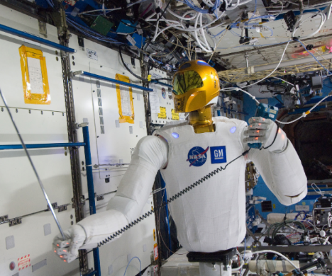  
   (Amazon, 2013)
2. **Radiation Tolerant Computer Mission on the ISS**We know that radiation is extremely harmful to humans, but it is also able to fry circuit boards by energizing them and causing malfunctions in their stored data. This experiment is one that tests the limits of computer hardware with radiation. The scientists associated with this experiment are trying to invent a laptop that can survive the vacuum of space for use on EVAs and backup communications in the event of depressurization.

# Skills Needed

When applying for the astronaut candidate program, applicants with a lot of flight time are preferred; however, as mentioned in the requirements, flight time is not necessary. Therefore, the CSA and NASA have combined efforts in making a 2-year astronaut training program. Here is a simple breakdown of the comprehensive program:

* Learn how to perform tasks in low- or no- gravity environments in the Neutral Buoyancy Laboratory (used to simulate weightlessness or free fall)
* Learn Russian!
* Understand all technical aspects (including on-board computers and many different types of instruments) about the Soyuz capsule
  + The Russian Soyuz capsule is the only capsule capable of taking astronauts from the surface of Earth to the ISS, ever since the cancellation of NASA’s Shuttle Program in 2011
* Learn and practice basic spacecraft functions such as takeoff, docking and landing
  + Learn how to deal with emergencies or failure of any equipment that would cause complications in any of the above functions
* Learn how to use the Canadarm 2 to…
  + Catch and dock unmanned capsules containing supplies along with manned capsules containing astronauts
  + Move astronauts carefully during spacewalks
* Understand the dangers of space travel due to the hostile environment and how to carry out emergency procedures to handle these dangers (e.g. Depressurization, fires and air contamination with gases such as ammonia)
* Go on space mission simulations to get a better feel for the environment and to prepare more. Current simulations include…
  + The Cooperative Adventure for Valuing and Exercising Human Behaviour and Performance Skills (CAVES) Underground Experiment
    - This mission simulation takes place 4km underground and tackles some of the challenges of colonizing another planet in the near future along with dealing with extremely hostile environments. This mission also strengthens team-building skills and teaches astronauts to take into account their surroundings while carrying out technical tasks.
  + The NASA Extreme Environment Mission Operations (NEEMO) Underwater Experiment
    - This mission simulation is another one that takes place in an extreme environment, while being 19m underground, lasting around 10 days in total. This simulation trains astronauts to survive together in an unknown environment while working on scientific experiments. This simulation is very similar to the dangers of the ISS, and is extremely useful to simulate spacewalks.

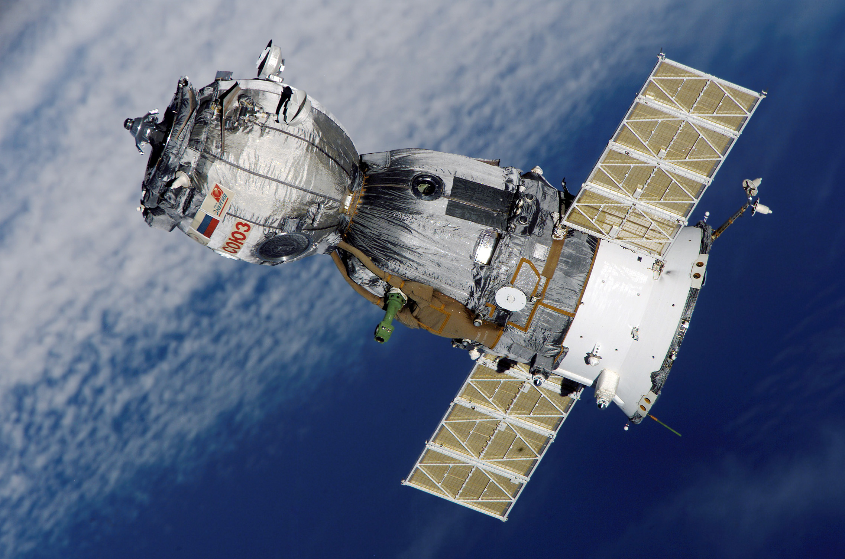

(NASA, 2014)

# Requirements

## Basic Requirements

Some of the very basic requirements, including educational requirements, to apply for employment as an astronaut in the Canadian Space Agency (CSA) or in the National Aerospace and Space Administration (NASA) include:

* **CSA**  
  Reside in Canada or be a Canadian citizen residing abroad; preference will be given to Canadian citizens  
  **NASA**Must be citizens of the United States or have a valid dual-citizenship.
* Fluent in either English or French, but knowing both is a very useful asset
* Bachelor’s degree from a recognized university in engineering or other sciences, including biology, COMPUTER SCIENCE, COMPUTER HARDWARE, Earth and space sciences, etc.  
  OR  
  A doctorate in medicine or dentistry
* At least three years of relevant professional experience in whatever field the applicant specializes in or in a field related to space sciences  
  OR  
  Be licensed to practice medicine in Canada

## Physical and Medical Requirements

Employment as an astronaut is both very physically and mentally demanding, so the applicant’s medical condition must be top-notch. Also, the space crafts that take humans from Earth into space have very specific requirements for the passengers that they carry that cannot be worked around, simply because of the physics. Currently, there is only one space craft that can take humans to the International Space Station with a high enough success rate; the Soyuz capsule. Requirements are as follows:

* Height: Between 149.5 cm and 190.5 cm
* Weight: Between 50 kg and 95 kg
* Visual Acuity: 20/20 or better in each eye, with or without correction and without any complications  
  Most organizations hiring astronauts recommend that no applicant goes through eye correction only for becoming an astronaut and not for any other reasons
* Not colour blind
* Blood pressure: Not higher than 140/90 mm Hg, measured in a sitting position
* Auditory acuity: Applicant must have normal hearing

# Typical Salary and Benefits

Employment as an astronaut offers some of the best salaries in the world. In NASA, the starting salary is $85, 860.00 CAD and an astronaut can earn up to $190, 545.00 CAD a year! Here is just a quick overview of the benefits an astronaut would get:

* Going into space provides access to cutting-edge technology, and therefore, it is extremely exciting and challenging at the same time
* As mentioned before, the salary is very competitive along with one of the most comprehensive retirement plans
* Even though organizations like NASA have been downsizing, they have been able to meet all of their employees’ needs. Space organizations have extremely low turnover rates, so it is very unlikely that an astronaut will not be given the opportunity to stay in the post through his/her career
* The facilities (eg. The Neutral Buoyancy Lab) are very well-maintained, providing a wonderful work environment
* In addition to the high salary, astronauts receive a small amount of money to pay for your civil service pay to be competitive with others in the private sector
* Astronauts have a choice from a variety of Helath Maintenance Organizations (HMO) health plans, in which NASA will pay about 75% of the biweekly health benefit
* Most facilities have on-site clinics for minor illnesses, etc.
* Astronauts can get 4 hours of sick leave for each biweekly period from their training (Of course, not from space, but astronauts can have breaks when they work in the ISS from normal schedules). Astronauts may use up to 104 hours of their sick leave each year to care for sick relatives.
* Astronauts receive 100% pay during extended sick periods during training
* Astronauts receive 18 months of service in case of disabilities
* For jury duty leaves, you will receive additional pay
* NASA and CSA offer clean air commuting services to family members of astronauts, especially during launches or other missions
* CSA offers a tuition pay for courses relating to your job; however, this depends on case-by-case analysis

# Personal Reflection

The opportunity to be employed as a computer-hardware-based astronaut appeals to me a lot! Since a very young age, I’ve had a great interest in the space fields and wondered how it is possible to survive conditions so harsh. After seeing many images taken by astronauts, I was able to realize the beautiful cooperation that takes place in space despite differences in race, colour and ethnicity. There is no war in space, only peace, and this is what keeps moving humanity forward.

Without the distractions faced on Earth, I believe that I would be able to make a change for the better by working in space as an astronaut by making discoveries in the fields of the computer science and computer hardware. These are the fields that I would specialize in when I grow up, so these are the fields I would love to innovate in as well. This is why the employment option to become an astronaut appeals to me very much.

# Potential Companies that Would Hire Astronauts

* Organizations
  + NASA (National Aeronautics and Space Administration)
  + CSA (Canadian Space Agency)
  + ESA (European Space Agency)
  + JAXA (Japan Aerospace Exploration Agency)
* Private Companies
  + Boeing
  + SpaceX
  + Virgin Galactic

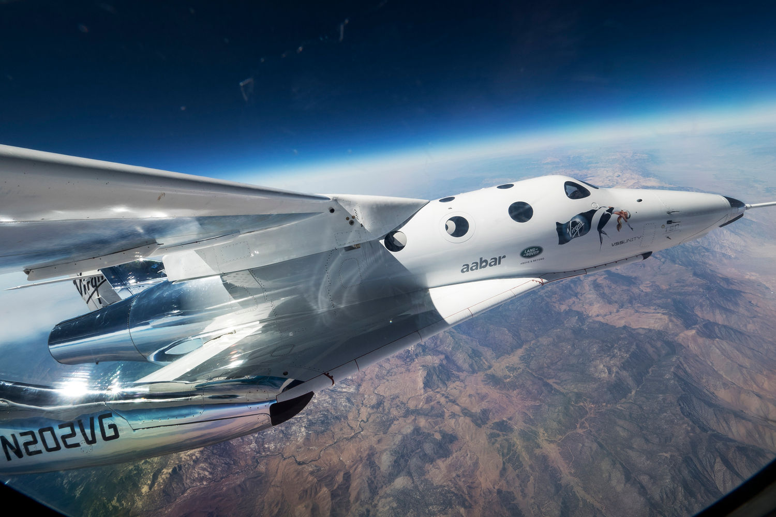

(Virgin Galactic, 2012)

# Summary

Astronauts are people that try to push the edges of our knowledge by learning, sharing and exploring the vast skies using science and technology. They are the people that truly carry our nations forward.

Space is the only place in this world that has to dividers separating countries, so international diversity is a big contributor in the jobs of astronauts. Seeing the sciences combined with a lot of cooperation, the jobs of astronauts is one that is both dangerous, but beautiful at the same time!

# Citations

## Text Citations

Melanie. (2017). Astronaut job description, career as a astronaut, salary, employment - definition and nature of the work, education and training requirements, getting the job. Retrieved January 10, 2017, from <http://careers.stateuniversity.com/pages/7831/Astronaut.html>

Government of Canada, & Canadian Space Agency. (2016, August 16). Requirements and conditions of employment for astronauts. Retrieved January 12, 2017, from <http://www.asc-csa.gc.ca/eng/astronauts/how-to-become-an-astronaut/requirements-and-conditions.asp>

Government of Canada, & Canadian Space Agency. (2016, June 17). About the job. Retrieved January 12, 2017, from <http://www.asc-csa.gc.ca/eng/astronauts/about-the-job/default.asp>

Collins, D. (2015, April 8). Astronaut requirements. Retrieved January 12, 2017, from <https://www.nasa.gov/audience/forstudents/postsecondary/features/F_Astronaut_Requirements.html>